**DAILY ONLINE ACTIVITIES SUMMARY**

|  |  |  |  |  |  |  |  |  |
| --- | --- | --- | --- | --- | --- | --- | --- | --- |
| **Date:** | **06/07/2020** | | | | | **Name:** | **Hanan Saleem Baji** | |
| **Sem & Sec** | **4th SEM 'A' Section** | | | | | **USN:** | **4AL18CS024** | |
| **Online Test Summary** | | | | | | | | |
| **Subject** | | N/A | | | | | | |
| **Max. Marks** | | N/A | | **Score** | | | N/A | |
| **Certification Course Summary** | | | | | | | | |
| **Course** | **1.Introduction to full stack development** | | | | | | | |
| **Certificate Provider** | | | **1. Great Learning Academy** | | **Duration** | | | **1. 3 hour** |
| **Coding Challenges** | | | | | | | | |
| **Problem Statement:** 1. Write a Java program to find the Nth natural number with exactly two bits set.  .  For example | | | | | | | | |
| **Status: completed** | | | | | | | | |
| **Uploaded the report in Github** | | | | | **Yes** | | | |
| **If yes Repository name** | | | | | <https://github.com/saleemhananbaji/Java-coding> | | | |
| **Uploaded the report in slack** | | | | | **Yes** | | | |

Certification Course Details: As the continuation of online course, I have completed Alt attribute and Unordered lists of full stack development.

Snapshot:

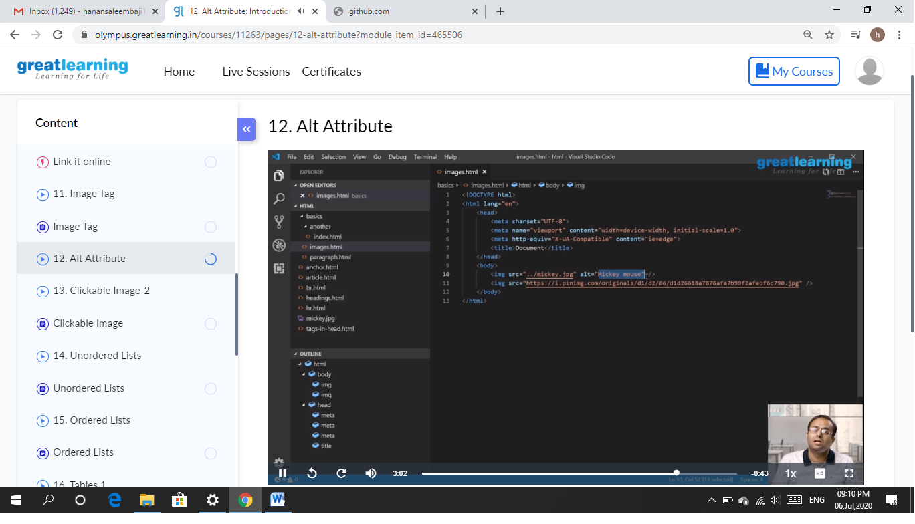

CODING CHALLENGES DETAILS: Problem statements

1. Write a Java program to find the Nth natural number with exactly two bits set.

Solution: Uploaded it in github

Snapshot:

